MLA0105 - Artificial Intelligence and Expert Systems for Gaming
Exp-41:-Birds
Code:
% Facts
bird(sparrow).
bird(penguin).
bird(eagle).
can_fly(sparrow).
can_fly(eagle)
% Rules
flies(Bird) :- can_fly(Bird).
flies(Bird) :- bird(Bird), \+ can_fly(Bird), write('This bird cannot fly.').
Output:
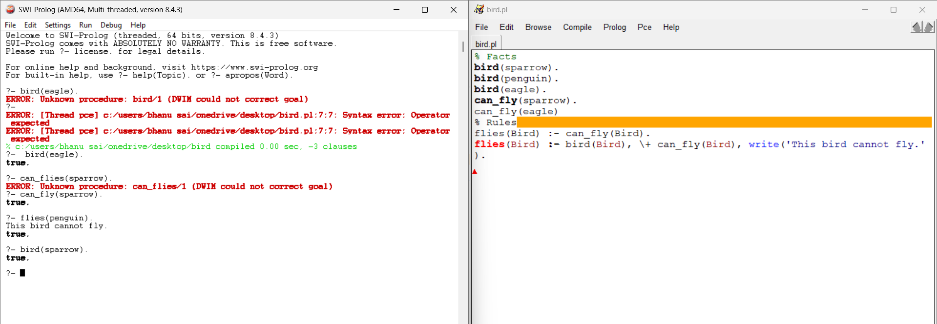
Exp-42:- Date Of Birth
Code:
% --- Facts: name and DOB (YYYY,MM,DD) ---
dob(john, 1990, 5, 12).
dob(ravi, 1985, 9, 22).
dob(anjali, 2002, 11, 3).
dob(kiran, 1995, 3, 19).
dob(sita, 1988, 7, 7).
% --- Rules ---
% calculate age
age(Name, Age) :-
dob(Name, Y, _, _),
Age is 2025 - Y.
% a) Retrieve DOB
get_dob(Name, Y, M, D) :- dob(Name, Y, M, D).
% b) Find people older than given age
older_than(AgeLimit, Name) :-
age(Name, Age),
Age > AgeLimit.
% c) Youngest person
youngest(Name) :-
dob(Name, Y,_,_),
\+ (dob(_, Y2,_,_), Y2 > Y).
% d) Check if one person older than another
older(Person1, Person2) :-
age(Person1, A1),
age(Person2, A2),
A1 > A2.
Output:
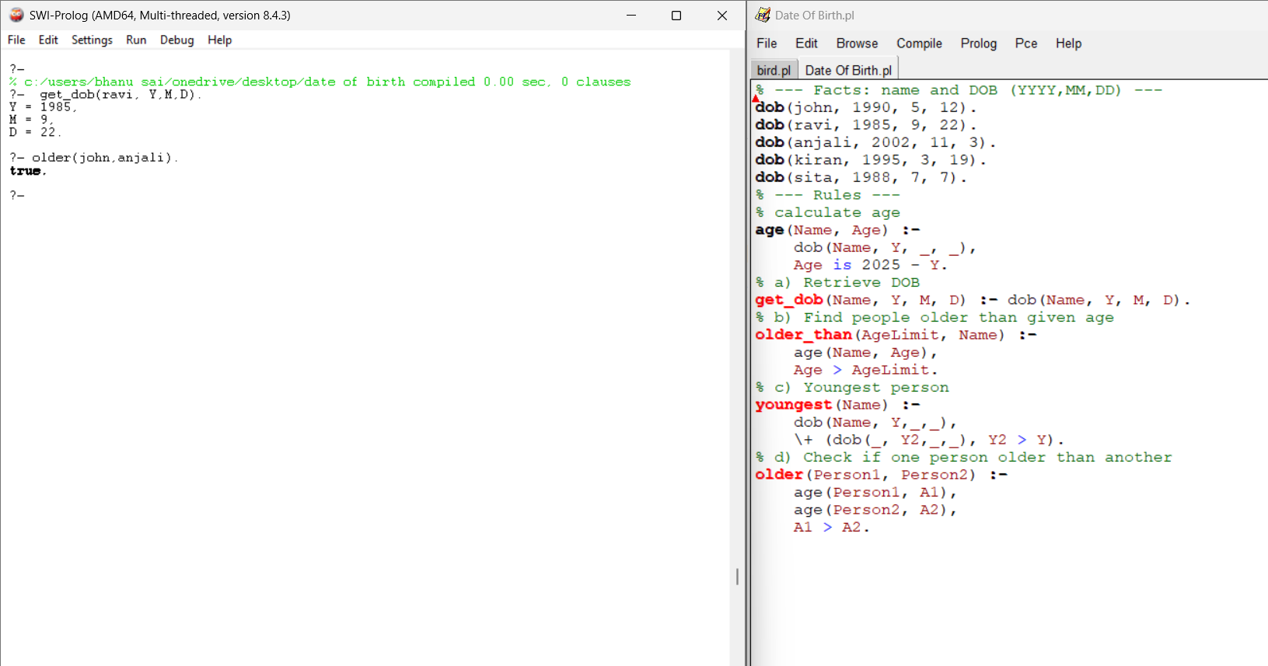

Exp-43 :- Mammal or Bird
Code:
% Facts
animal(tiger).
animal(elephant).
animal(eagle).
animal(sparrow).
animal(penguin).
mammal(tiger).
mammal(elephant).
bird(eagle).
bird(sparrow).
bird(penguin).
% Rules
is_mammal(X) :- mammal(X).
is_bird(X) :- bird(X).
Output:
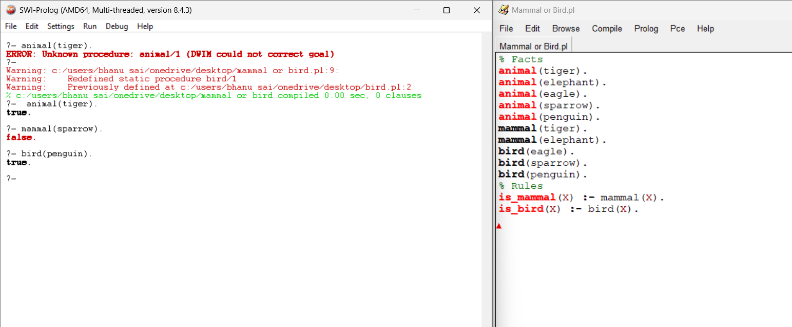

Exp-44:-Diet Recommendation
Code:
% Facts: diseases
disease(diabetes).
disease(hypertension).
disease(obesity).
% Diet Recommendations
diet(diabetes, 'Avoid sugar, take whole grains, leafy vegetables.').
diet(hypertension, 'Low salt diet, avoid fried foods, eat bananas.').
diet(obesity, 'Low-calorie diet, avoid junk food, eat more fruits.').
% Rule to suggest diet
suggest_diet(Disease, Diet) :-
diet(Disease, Diet).
Output:
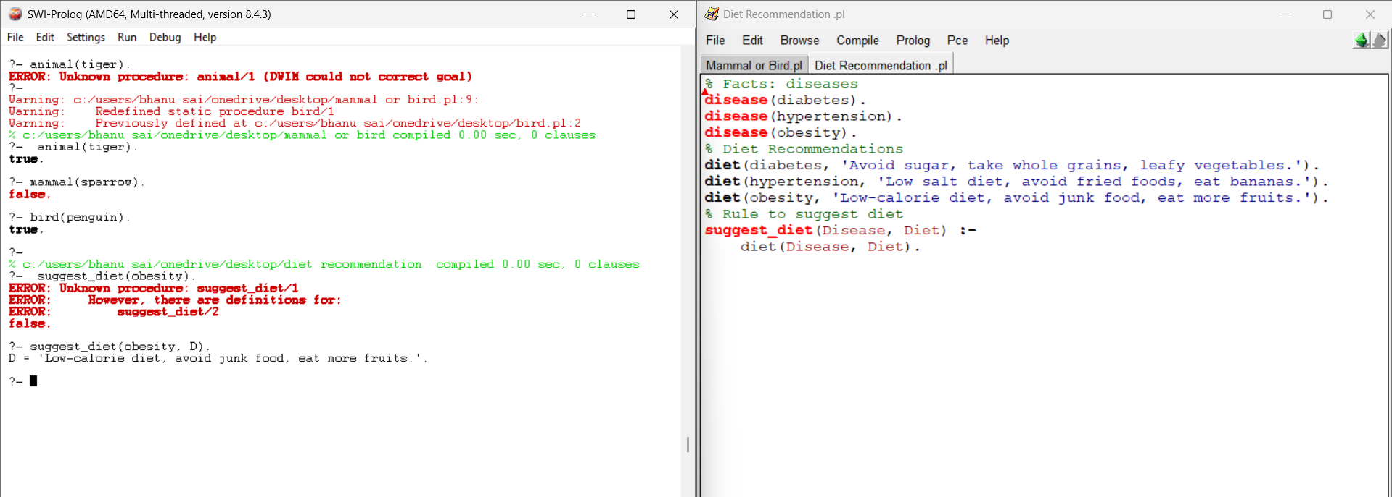

Exp-45:- Fruits and Colors
Code:
% Fruits and their colors
fruit_color(apple, red).
fruit_color(banana, yellow).
fruit_color(orange, orange).
fruit_color(grapes, green).
fruit_color(blueberry, blue).
fruit_color(watermelon, green).
fruit_color(papaya, orange).
fruit_color(cherry, red).
% Rule to get fruit and color
get_fruit_color(Fruit, Color) :- fruit_color(Fruit, Color).
Output:
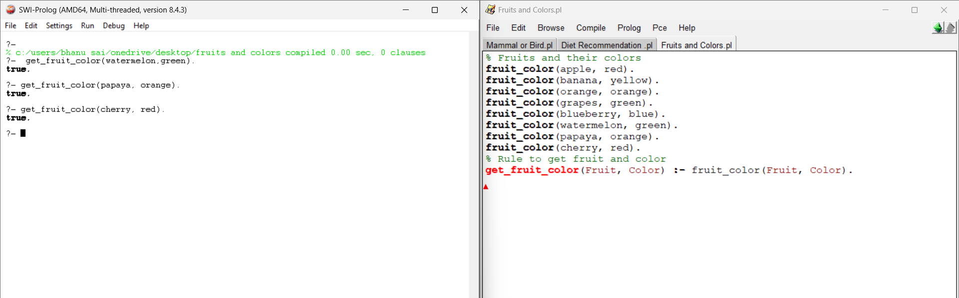

Exp-46:- Exam question generator
Code:
% facts
student(alex, 101).
student(maya, 102).
student(raj, 103).
student(sneha, 104).
teacher(dr_singh, cs101).
teacher(ms_khan, ma101).
teacher(prof_rao, ph101).
subject(cs101, 'Computer Science I').
subject(ma101, 'Calculus I').
subject(ph101, 'Physics I').
% Question templates: create fill-in-the-blank questions and print them
% Q1: Student - roll number
make_question(1) :-
student(Name, Roll),
format('Fill in the blank: The student with roll number ~w is _______.~n', [Roll]),
format('Answer: ~w~n~n', [Name]),
fail.
make_question(1).
% Q2: Teacher and subject code
make_question(2) :-
teacher(TName, Code),
subject(Code, Subj),
format('Fill in the blank: The teacher of ~w (code: ~w) is _______.~n', [Subj, Code]),
format('Answer: ~w~n~n', [TName]),
fail.
make_question(2).
% Q3: Subject code to subject name
make_question(3) :-
subject(Code, Name),
format('Fill in the blank: The subject with code ~w is _______.~n', [Code]),
format('Answer: ~w~n~n', [Name]),
fail.
make_question(3).
% convenience predicate to generate all questions (prints them)
generate_all_questions :-
format('--- Question set (students) ---~n', []),
make_question(1),
format('--- Question set (teachers & subjects) ---~n', []),
make_question(2),
format('--- Question set (codes -> name) ---~n', []),
make_question(3).

Output:
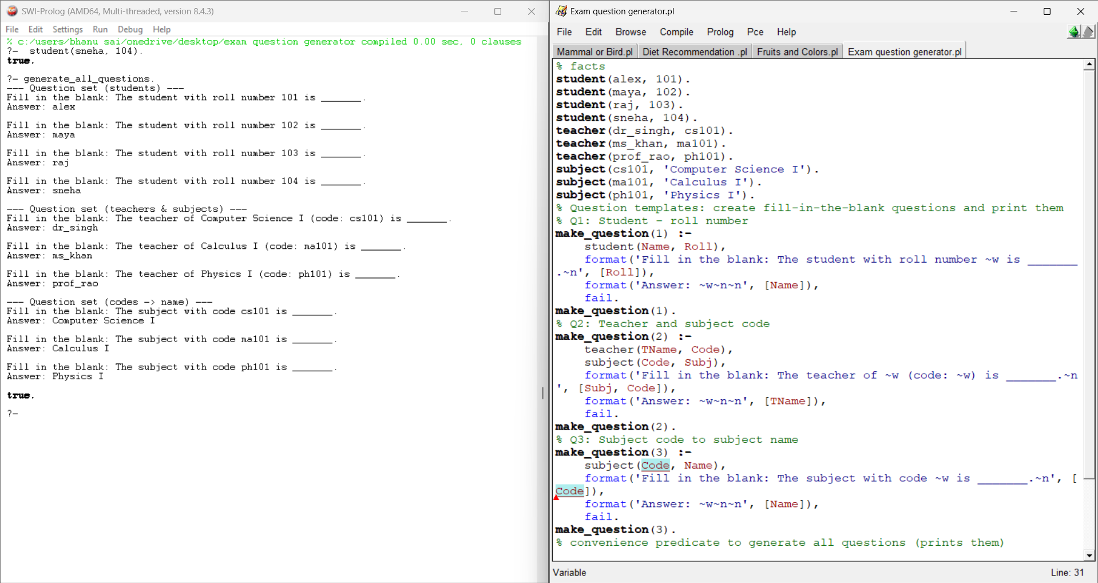

Exp-47:- Forward chaining scenario
Code:
% facts: genders
male(john).
male(amit).
female(sara).
female(kavya).

% facts: has_child(Parent, Child)
has_child(john, neha).
has_child(amit, rishi).
has_child(kavya, arun).

% rule: someone is a parent if they have a child and their gender is known
is_parent(Person) :-
( male(Person) ; female(Person) ),
has_child(Person, _).

% optional: more explicit rules
is_father(Person) :- male(Person), has_child(Person, _).
is_mother(Person) :- female(Person), has_child(Person, _).
Output:
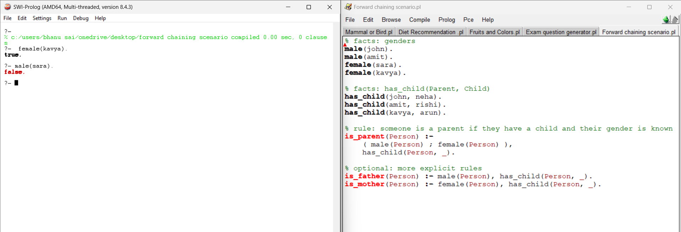

Exp:-48: PLANETS
Code:
% Facts: position(Number from Sun), distance_from_sun_in_AU (optional), mass_in_earth_masses
% positions: 1 = Mercury, 2 = Venus, 3 = Earth, 4 = Mars, 5 = Jupiter, 6 = Saturn, 7 = Uranus, 8 = Neptune

planet(mercury).
planet(venus).
planet(earth).
planet(mars).
planet(jupiter).
planet(saturn).
planet(uranus).
planet(neptune).

% a) Mercury: distance from Sun (AU) and mass (in Earth masses)
position(mercury, 1).
distance_from_sun(mercury, 0.39). % AU (approx.)
mass_in_earth_masses(mercury, 0.055). % Mercury mass ≈ 0.055 Earth masses

% b) Saturn: orbital period and day length
position(saturn, 6).
orbital_period_days(saturn, 10759). % Saturn orbital period ≈ 10759 Earth days (~29.5 years)
day_length_hours(saturn, 10.7). % Saturn day length ≈ 10.7 hours

% other planets (positions provided so rule works)
position(venus, 2).
position(earth, 3).
position(mars, 4).
position(jupiter, 5).
position(uranus, 7).
position(neptune, 8).

% c) rule: distance between planets based on positions (number of positions apart)
% Here "distance" is the difference in position index (an integer count).
distance_between(P1, P2, Dist) :-
position(P1, Pos1),
position(P2, Pos2),
( Pos1 >= Pos2 -> Dist is Pos1 - Pos2 ; Dist is Pos2 - Pos1 ).

% d) planets closer to the Sun than Earth
closer_to_sun_than_earth(P) :-
position(P, PosP),
position(earth, PosE),
PosP < PosE.
Output:
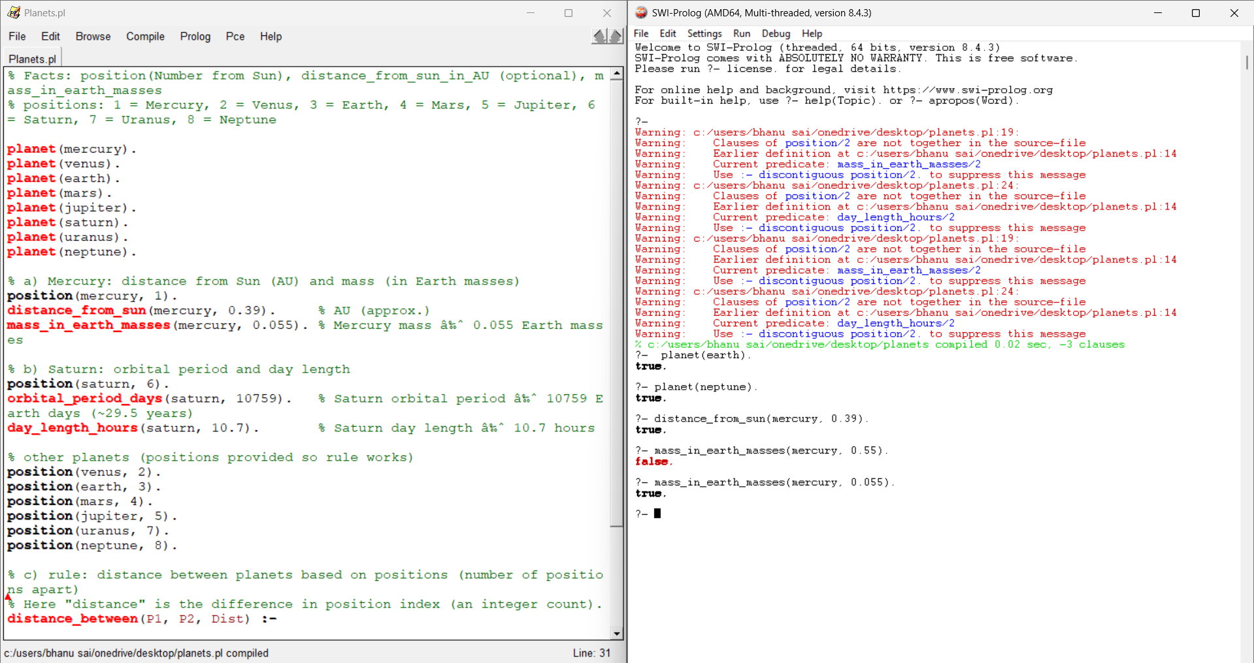

Exp:-49:Symptom-based diagnosis with a simple interactive interface
Code:
% Symptom facts (empty initially). We'll assert user symptoms at runtime.
% Known symptoms (for documentation)
known_symptom(fever).
known_symptom(cough).
known_symptom(sore_throat).
known_symptom(runny_nose).
known_symptom(headache).
known_symptom(body_pain).
known_symptom(shortness_of_breath).
known_symptom(fatigue).
known_symptom(loss_of_smell).
% Diseases and their required symptoms (simple rules)
disease(flu) :-
have(fever),
have(cough),
have(body_pain).

disease(common_cold) :-
have(runny_nose),
have(sore_throat).
disease(covid19) :-
have(fever),
have(cough),
have(loss_of_smell).
disease(migraine) :-
have(headache),
have(nausea) . % note: nausea can be asserted by user if present
% Diagnosis logic: collect matching diseases
diagnose(Diseases) :-
% findall to collect all diseases for which disease/1 succeeds
findall(D, disease(D), DiseasesUnsorted),
list_to_set(DiseasesUnsorted, Diseases). % remove duplicates
% Interactive: ask symptoms one by one, stop by entering 'done'.
ask_symptoms :-
format('Enter symptoms one by one. When finished type done.~n', []),
retractall(have(_)), % clear previous inputs
ask_loop.
ask_loop :-
write('Symptom: '),
read(Input),
( Input == done ->
write('Finished entering symptoms.'), nl
;
( known_symptom(Input) -> assertz(have(Input))
; format('Warning: "~w" is not in known_symptom list, but I will record it.~n', [Input]), assertz(have(Input))
),
ask_loop
).

% convenience predicate to run the interactive diagnosis
run_diagnosis :-
ask_symptoms,
diagnose(Ds),
( Ds = [] -> write('No matching disease found based on given symptoms.'), nl
; format('Possible diagnoses: ~w~n', [Ds])
).
% small helper to show current recorded symptoms
show_symptoms :-
findall(S, have(S), L),
format('Current symptoms: ~w~n', [L]).
Output:
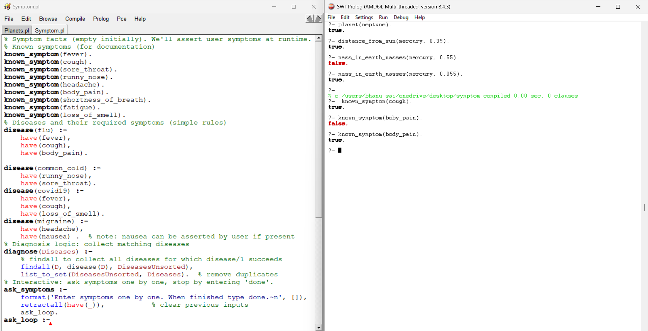

Exp-50:-Family Tree
Code:
% ---- FACTS ----
% a) John is the father of Lisa.
father(john, lisa).
% b) Mary is the mother of Lisa and Mike.
mother(mary, lisa).
mother(mary, mike).
% c) Lisa is the sister of Mike.
sister(lisa, mike).
% d) Tom is the father of Mary.
father(tom, mary).
% e) Mike is the father of Emma.
father(mike, emma).
% f) Emma is the mother of Olivia.
mother(emma, olivia).
% g) Tom is the grandfather of Olivia.
% (We will not add this as a fact—our rules will derive it.)
% ---- RULES ----
% parent rule
parent(X, Y) :- father(X, Y).
parent(X, Y) :- mother(X, Y).
% grandparent rule
grandparent(X, Y) :-
parent(X, Z),
parent(Z, Y).
% grandfather
grandfather(X, Y) :-
father(X, Z),
parent(Z, Y).
% grandmother
grandmother(X, Y) :-
mother(X, Z),
parent(Z, Y).
% sibling rules
sibling(X, Y) :-
parent(P, X),
parent(P, Y),
X \= Y.
% sister rule (A sister is a female sibling)
sister_of(X, Y) :-
sister(X, Y). % directly given fact

Output:
